**Set Actions**

Tableau set actions are a new a version 2018.3 type of dashboard action that will unlock new user experiences by allowing you to dynamically control which dimension members are included in a set.

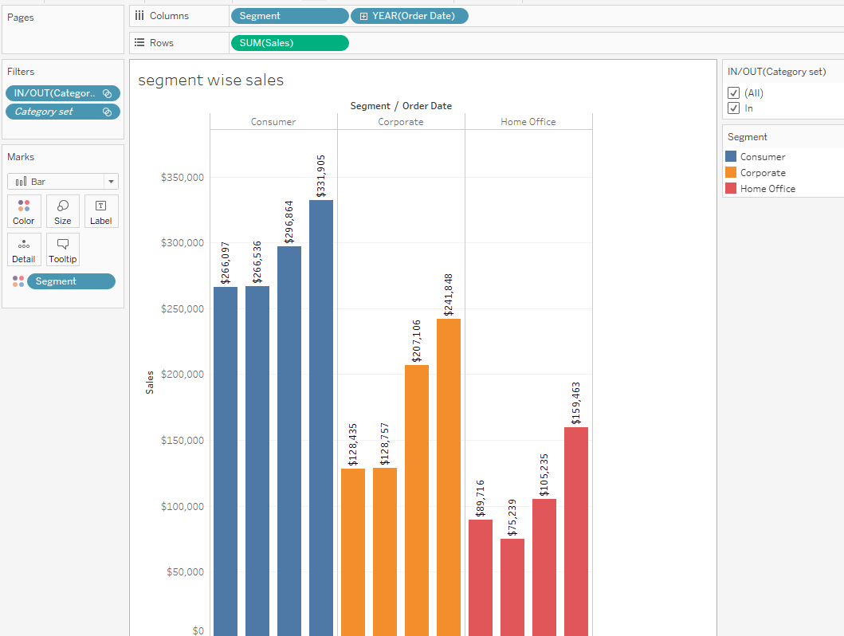

Here I am taking the segment and year of order date as in columns and sales in rows and segment as in color.

First I am creating the category-set for that

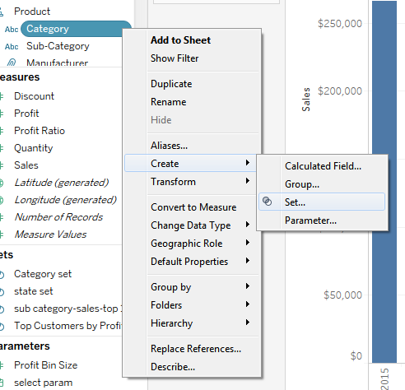

This one is sheet 1 and create sheet 2 as

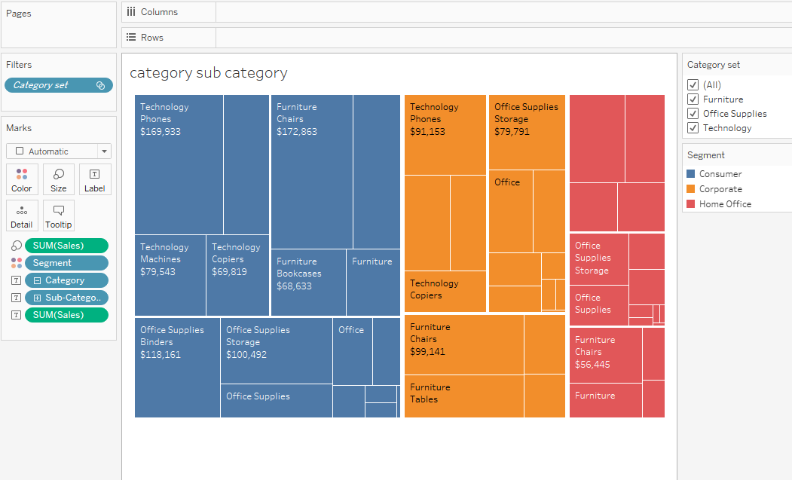

Here I am taking the sales in size, segment in color category in text and sub-category in text, sales in text and category set in filter.

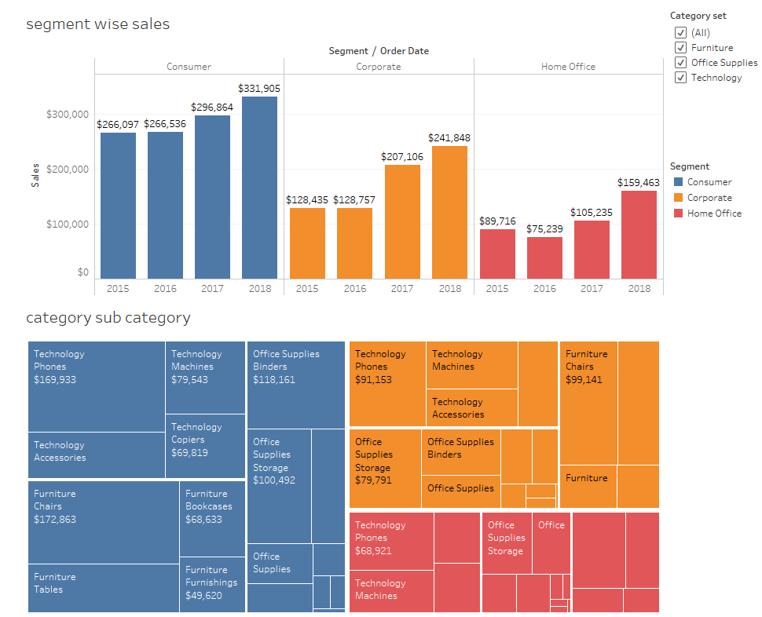

Here I am taking two sheets on one dashboard and if we select one category on second sheet it will drill down the data on first sheet, for that we will taking the set actions on dashboard as

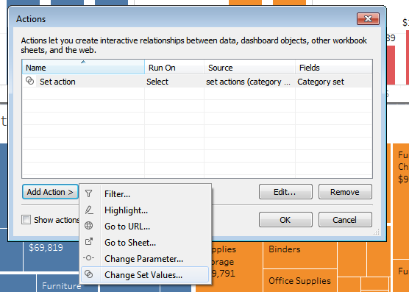

Here go to dashboard action and select as change set values

It will move to next popup it will ask as name of the action and source sheet and target sheet.

Here I am giving the name as set action.

Select source sheet as in second sheet as (Category sub category) select and target sheet as data source as sample-superstore and select set as in category set and select radio button as Add all values to set.

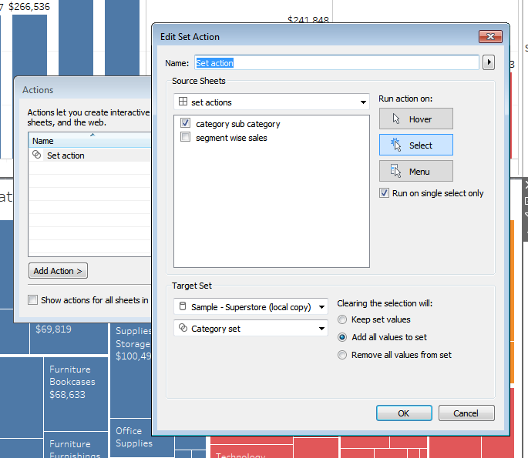

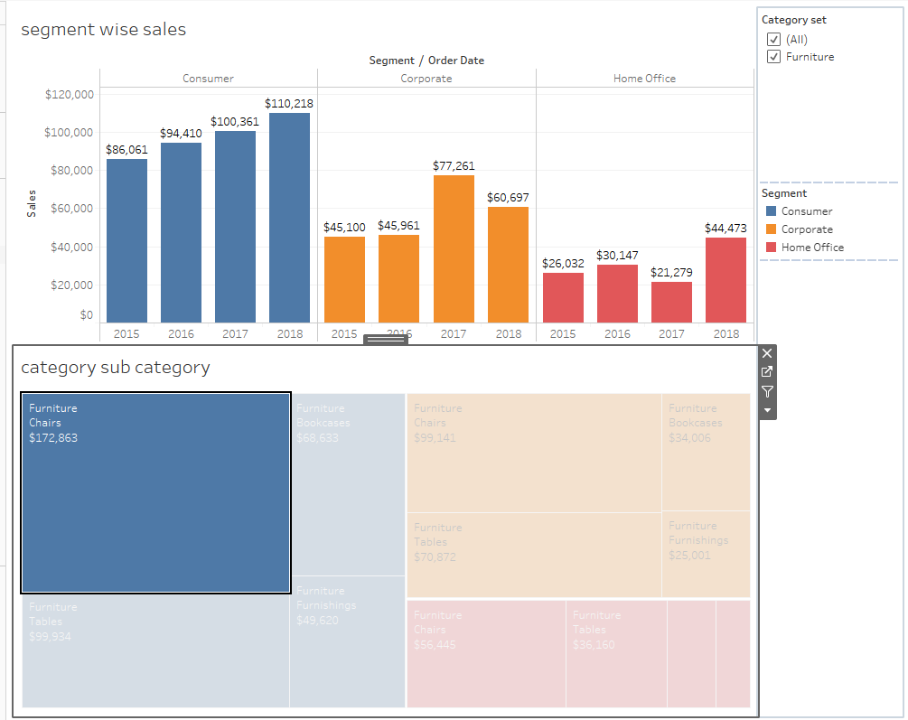

Here if we click on second sheet –category is in furniture and it will drill down to total data of sheet 1.

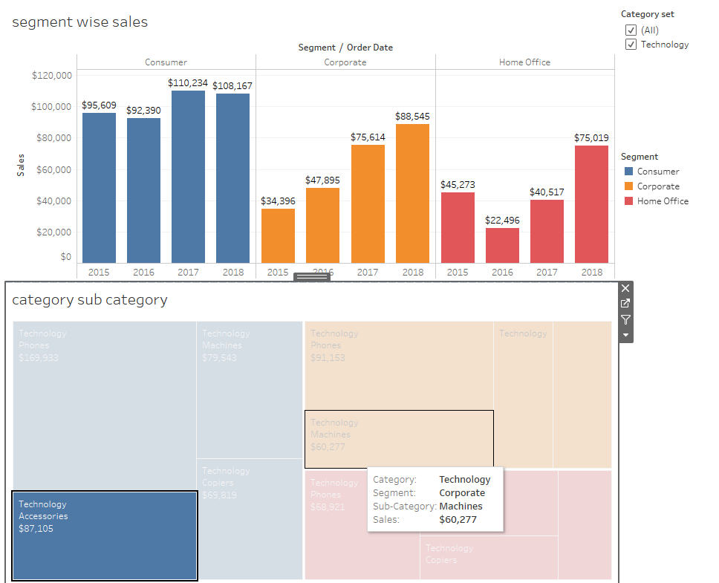

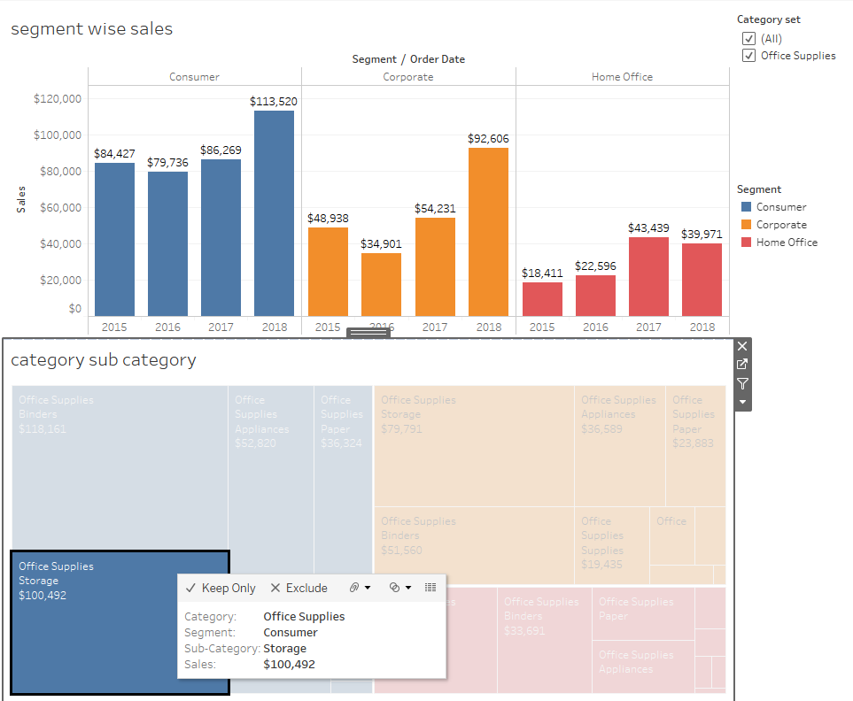

**Parameter Actions:**

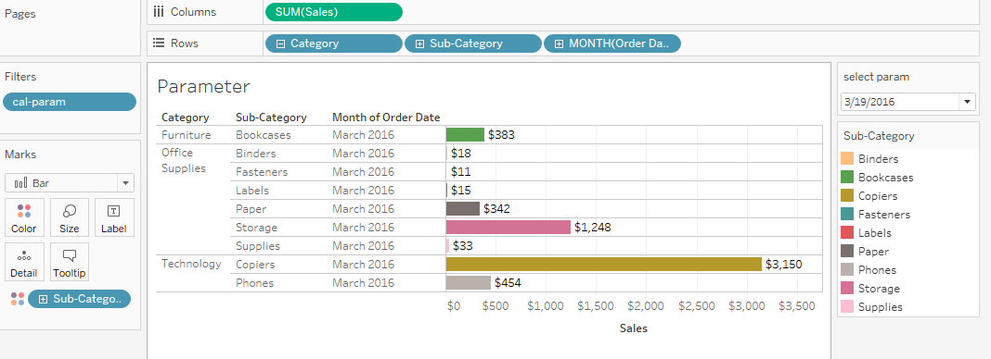

Here we are taking the sales as in columns, category –sub category and month of order date are in rows shelf.

First we need to create as one parameter:

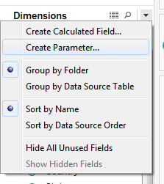

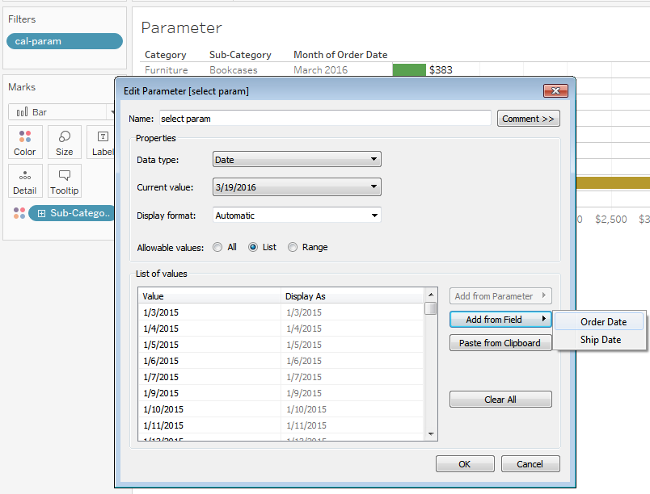

Create parameter and name as select param list taking as order date.

Parameter takes as in filters.

Here if we select parameter based on that data will drill down.

**Set Actions Proportional Brushing:**

Brushing is the simple act of directly selecting data in a chart. Imagine that your mouse is a paintbrush that you can use to select specific objects in a chart such as data points, bars, and lines by brushing across them or drawing an enclosure around them.

 Proportional brushing allows you to set up a dashboard action to enable you to use a dimension from one chart, to highlight a section of another chart, without that dimension needing to be in the view of the second chart.

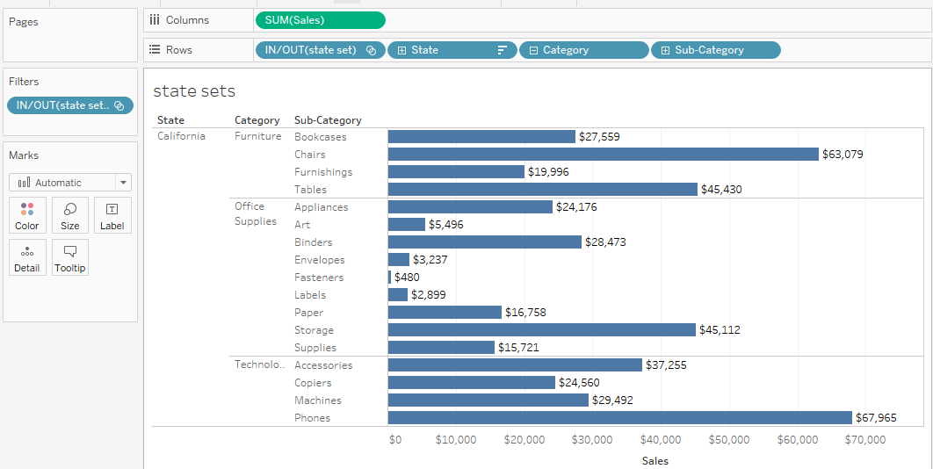

Here we are taking the sales as in columns,

First we need to create set as state wise state, category, subcategory as in rows shelf, set as in filter takes as all members in the set values.

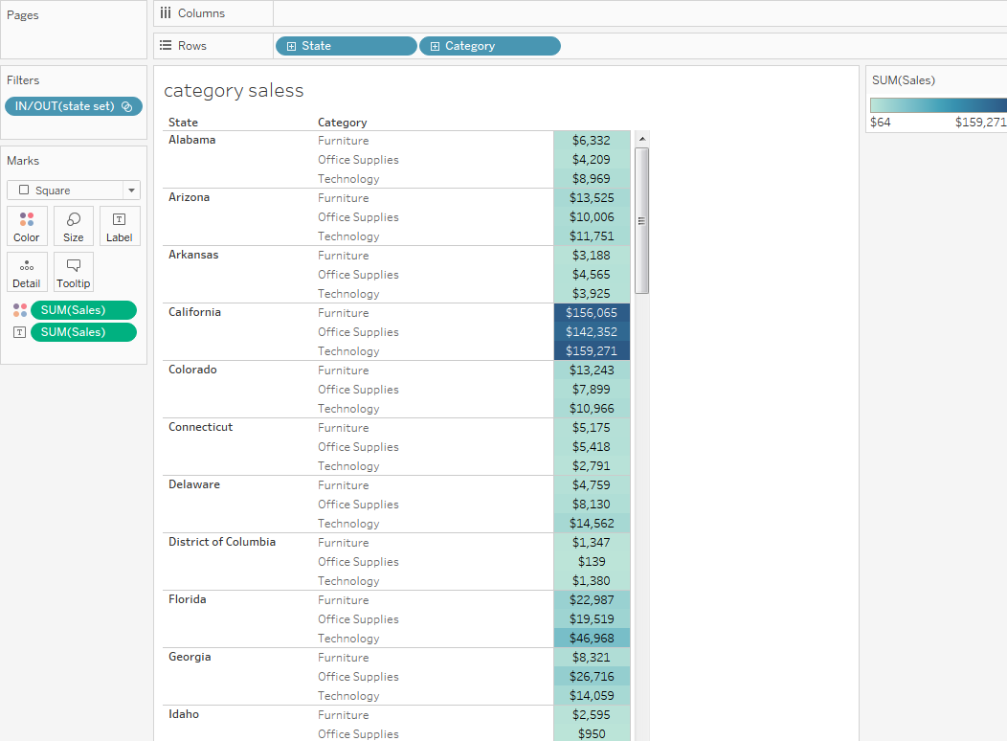

Here we are taking the state and category as in row, sales as in text and color. Set as in filter.

If we select sheet 1 – any state and it will display all the data of sheet 2 depends on the state set.

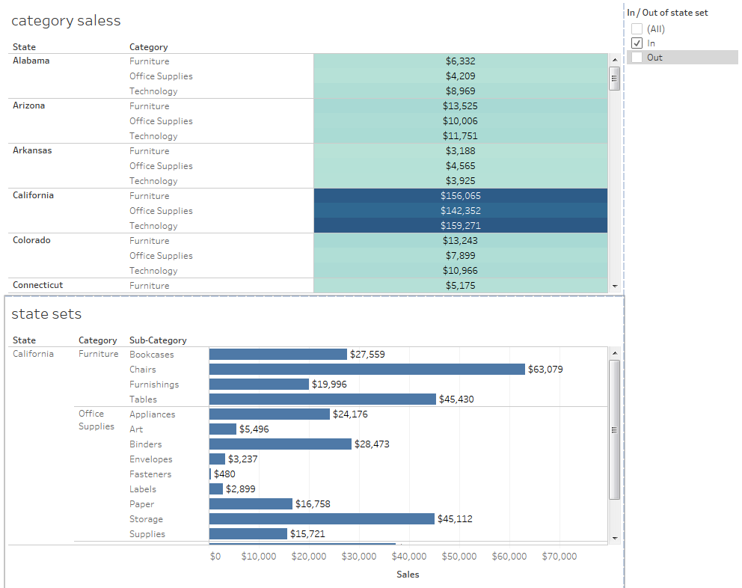

Another method:

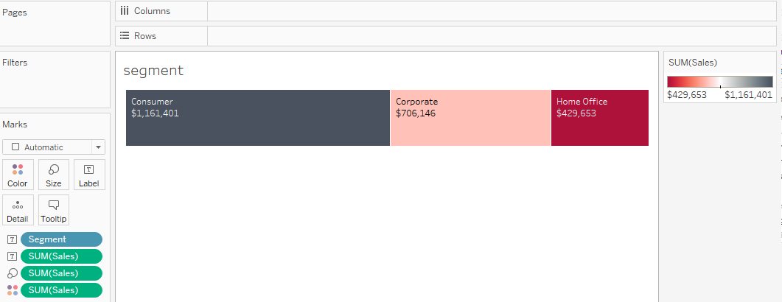

Here I am taking the segment and sales are in color and text.

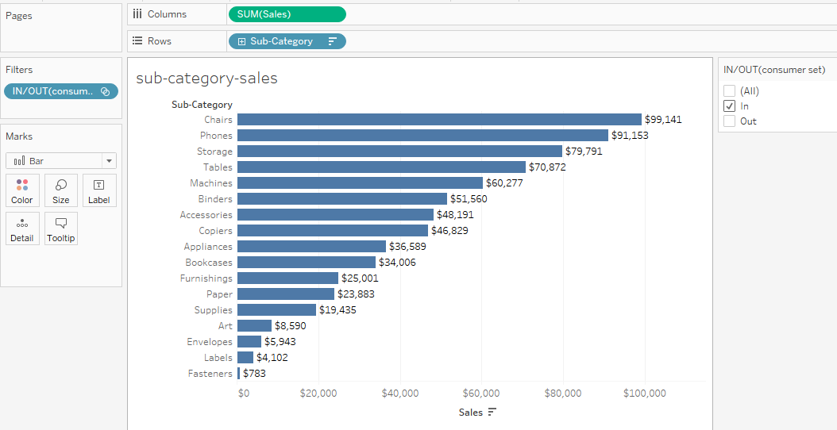

Here sales as in columns, sub-category as in rows shelf and first we need to create one set as segment-set (taking as consumer).

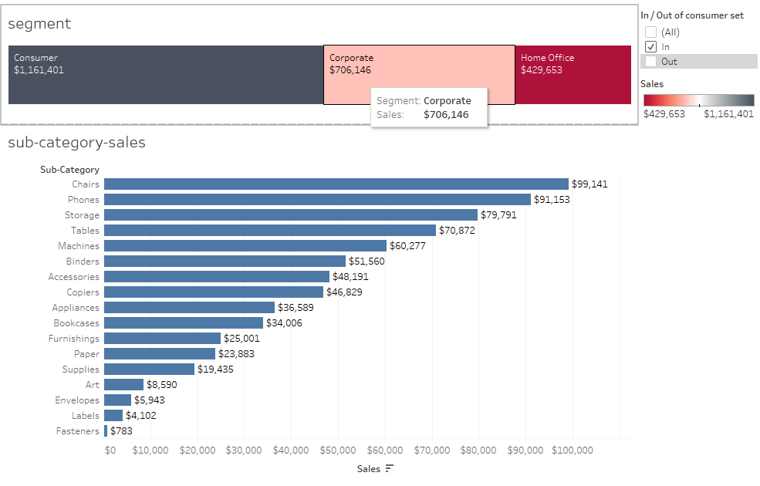

If we hover on segment then data will drill down to second sheet it will display like that.

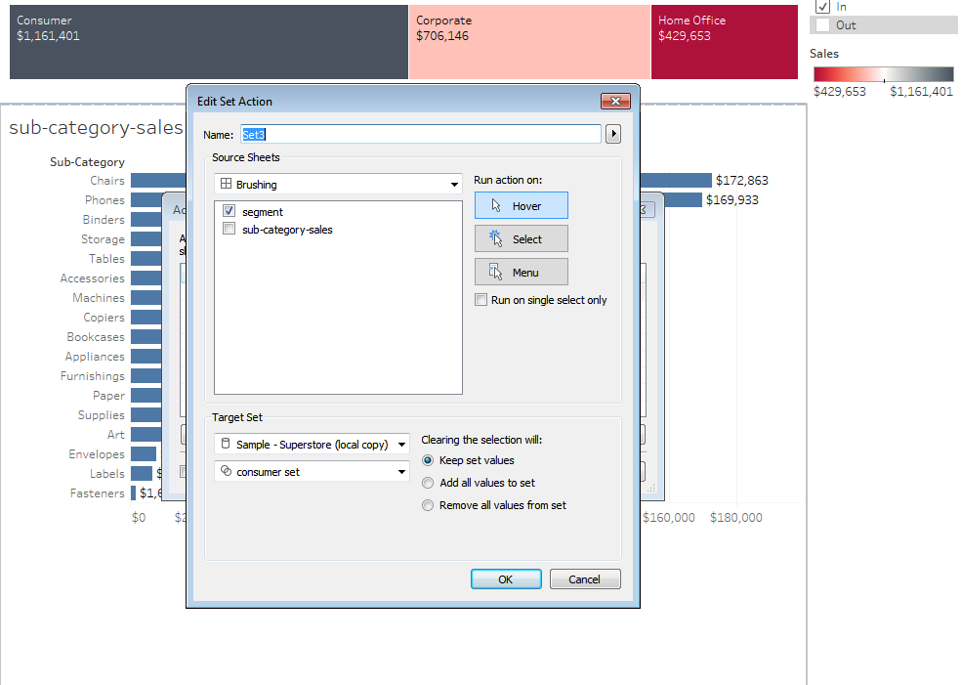

The main difference is that parameter action is a single select.